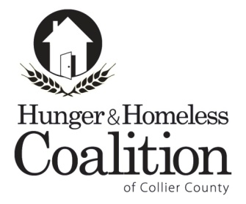

**CoC Executive Committee Meeting Agenda**

**April 7, 2016 - 3:00 pm**

Iberia Bank  
5247 Golden Gate Parkway, Naples

**Old Business**

1. **2016 PIT Count**
2. **HMIS update**
3. **Membership**
4. **Coordinated Assessment**

**New Business**

1. **Vice Chair Vacancy**

**Other Business for the Good of the Order**

1. **Bridges Out of Poverty Initiative**
2. **Direct Services Meeting**
3. **Other**

**Next CoC Executive Committee Meeting:   
June 2, 2015 at 3 pm at Iberia Bank**