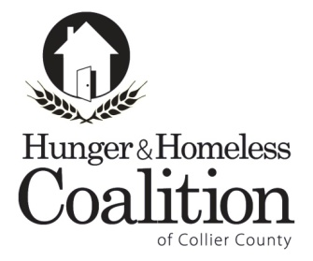

**CoC Executive Committee Meeting Agenda**

**June 2, 2016 - 3:00 pm**

Iberia Bank  
5247 Golden Gate Parkway, Naples

**Call To Order**

**Approval of Minutes – March CoC**

**Old Business**

1. **Chair & Vice Chair Vacancies**
2. **HMIS update**
3. **Membership**

**New Business**

1. **Grants**
   1. **Challenge**
   2. **TANF**
   3. **Consolidated Application**
2. **Ranking and Review**

**Announcements**

**Next CoC Executive Committee Meeting:   
July 7, 2015 at 3 pm at Iberia Bank**