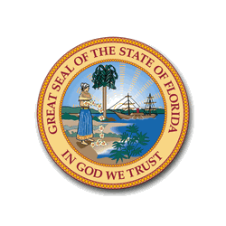
Florida’s Affordable Housing Shortage Leads to Rise in Homelessness Among Children, Elderly, Persons with Disabilities and Veterans in Collier County

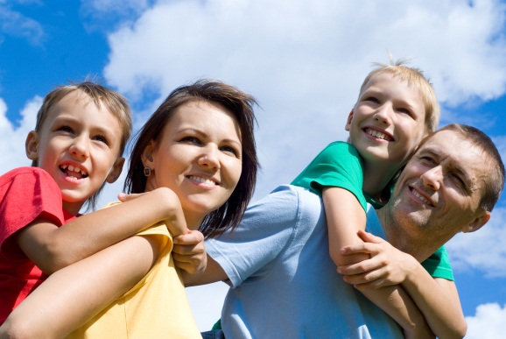
Since 2007, Florida has seen a significant increase in the rate of homelessness. 7,107 more Floridians experienced homelessness in 2012 than in 2007 - a nearly 15% increase. Nationally, during the same period, homelessness decreased 5.7%. (2012 Annual Homeless Assessment Report, Volume I; U.S. Department of Housing and Urban Development)
Making Ends Meet
An individual making the minimum wage of $7.79 per hour, working 40 hours a week, has a gross income of $1,350 per month. Average rent for a one-bedroom apartment in Florida is $813. As a result, this individual will pay 60% of their monthly income for rent.
Florida continues to have the third largest homeless population in the country; 8.7% of the nation's homeless live in Florida. It also has the third highest rate of unsheltered homeless persons (64.1%).

According to the 2013 Rental Market Study conducted by the University of Florida Shimberg Center for Housing, the number of Florida households that are renting rose from 411,008 in 2000, to 710,790 in 2011 – a nearly 73% increase. Roughly 29% of today’s renters have low income – earning just 60% of the area’s median income or less.
(U.S. Census Bureau, 2005 and 2011 American Community Survey)

Since 2007, the Florida Department of Education has seen a 106% increase in homeless and unstably housed students (www.fldoe.org/bsa/title1/pdf/HomelessEducationTrendData.pdf). Children who are homeless are sick four times more often than other children (National Center on Family Homelessness). These same children also go hungry at twice the rate of other children and have three times the rate of emotional and behavioral problems, including high rates of anxiety, depression, withdrawal and aggression, compared to children who have a permanent home. (www.homelesschildrenamerica.org).

In Collier County, there were 1054 homeless students in the school year 2012-2013.
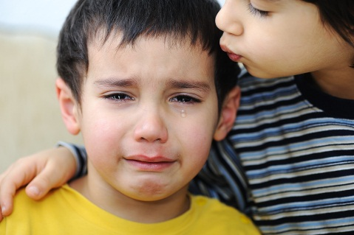
By age 12, 83% of homeless children had been exposed to at least one serious violent event. (National Center on Family Homelessness)

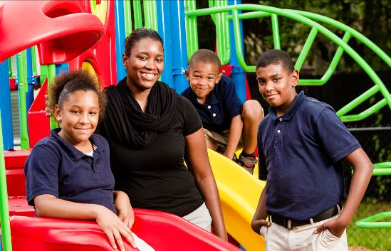

RECOMMENDATION
In its 2013 Council on Homelessness Report, Florida’s Council on Homelessness identified as a top priority the creation of housing that is affordable to Extremely Low-Income households (ELI –earning 30% or less of the area median income), especially households with Special Needs, a top priority. There are approximately 450,000 Extremely Low Income (ELI) renter households in Florida. For a family of four in Orlando this equates to earning $17,550 or less per year; for an elderly couple in the Panhandle, it equates to an annual income of $11, 550.
31,148 families with children
are homeless in Florida

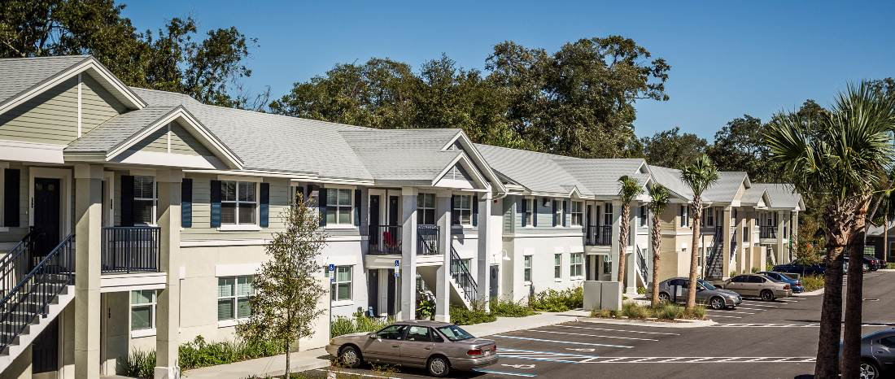A large majority (75%) of ELI households are cost burdened, spending 40% or more of their income on housing. Between 2005 and 2011, the number of cost-burdened ELI renter households increased 24%, from 256,357 in 2005 to 317,990 in 2011.
Supportive housing project for homeless families

An individual making the minimum wage of $7.79 per hour, working 40 hours a week has a gross income of $1,350 per month. Average rent for a one-bedroom apartment in Florida is $813. As a result, this individual will pay 60% of their monthly income for rent. Any change in the individual's income -- a cutback in hours, uninsured medical expenses, unanticipated car repairs -- may tip the scales and create another homeless household. Families face an even greater challenge and are the fastest growing segment of the homeless in Florida.

RATIONALE
Affordable housing is the key to reducing homelessness in our state. The Council on Homelessness recommends appropriating resources to Florida Housing Finance Corporation to produce housing for extremely low-income and homeless households. Across the state, the demand for housing that ELI households can afford far exceeds the supply. The 2013 Rental Market Study states that in most regions of the state that for every 100 ELI renter households there are 50 or fewer affordable and available units.

In 2012, Florida’s homeless included…
6,658 children, 5,109 households with at least one child,
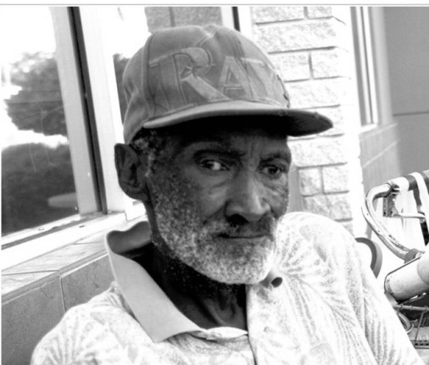
4,915 military veterans, and 14,320 persons with a
disabling condition.

Florida needs more than 643,000 rental units to help meet the current demand from low-income renters. By helping homeless families and individuals obtain short-term rental or utility assistance, we are able to reduce costs to the state.
16% of homeless individuals are Veterans
51% of homeless individuals report a disabling condition

ABOUT FLORIDA’S COUNCIL ON HOMELESSNESS
The Council on Homelessness was created in 2001 to develop policies and recommendations to reduce homelessness in Florida. Its mission is to develop and coordinate policy to reduce the prevalence and duration of homelessness, and work toward ending homelessness in Florida. The Council believes all of Florida's children, elders, persons with disabling conditions and veterans should have access to an affordable place to live.

The Council consists of 17 members, representing nine state agencies, four members appointed by the Governor, and four members representing statewide organizations and homeless advocacy groups. The agencies represented on the Council are: Agency for Health Care Administration, Department of Children & Families, Department of Corrections, Department of Economic Opportunity, Department of Education, Department of Health, Department of Veterans Affairs, Florida Housing Finance Corporation and Workforce Florida. The statewide organizations represented on the Council are: Florida Association of Counties, Florida Coalition for the Homeless, Florida League of Cities and Florida Supportive Housing Coalition. To learn more about the Council on Homelessness or to view the Council on Homelessness 2013 Report, visit http://www.dcf.state.fl.us/programs/homelessness/docs/2013CouncilReport.pdf.

